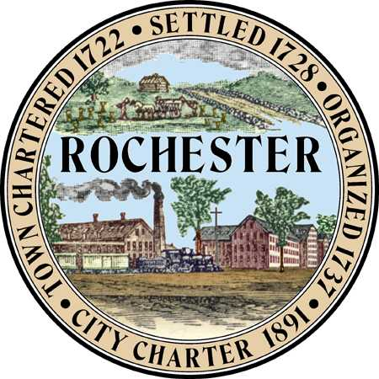
Planning & Development Department
Arts and Culture Commission
Matt Wyatt (Chair)
Eric Edema (Vice Chair)
Elaine Lauterborn
Michael Provost
Amy Regan

City Hall - Second Floor
31 Wakefield Street,
Rochester, New Hampshire 03867-1917
(603) 335-1338 - Fax (603) 335-7585
Web Site: www.rochesternh.net

AGENDA
ARTS AND CULTURE COMMISSION
Thursday, March 17, 2016 at 7 pm
City Council Conference Room
31 Wakefield Street, Rochester, NH
*see notes at end
__________________________________________________________________________

Call to Order

Approval of minutes for January 21, 2016

Call to Order

Rochester Art Awards Going Forward

Brochure
- Award nominees
- Food sponsor
- Music

Arts & Economic Prosperity Study

Downtown piano

City walking group

Safe places

Photography

Other business

Closing Remarks

Adjournment

********Next meeting is May 19

*Please note the following:
The public is invited to attend all meetings of the Arts and Culture Commission. Most meetings are not public hearings so the public may speak at the discretion of the chair/commission.

Contact the Planning and Development Department if you have questions or comments about these or any related matters or if you have a disability requiring special provisions.

