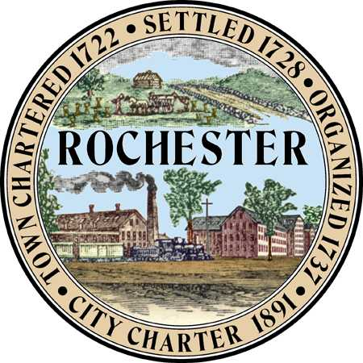
AGENDA

Rochester Conservation Commission

Meeting of March 22, 2017
6:30 P.M.

Police Department, Lecture Hall
(2nd floor via elevator)

Call to Order: Roll Call

1. Conservation Overlay District:
a) Real Estate Advisors Inc., 24 Jeremiah Lane (by Berry Surveying & Engineering/Walter Cheney) proposed 53-Lot subdivision for single and duplex housing proposal involving with wetland/wetland buffer impacts.
b) LaPerle Family Rev. Trust, Haven Hill Road Map + Lot #225 – 24-1 (by Norway Plains Assoc.) proposed 10-Lot subdivision involving wetland/wetland buffer impacts.
c) Waste Management, Rochester Neck Rd, Preliminary review of proposed landfill expansion involving with wetland/wetland buffer impacts.

2. Non-Public Session pursuant to RSA 91-A:3 II(d): Discussion of acquisition of real property and/or recent site walks and LACE sheets.

3. Minutes: Review Meeting Minutes of February 22, 2017

4. Correspondence: (emailed/sent prior to meeting): None scheduled.

5. Notice of Intent to Cut Wood or Timber / Intent to Excavate:
a) Notice of Intent to Excavate - Tax Map # 268-5, Rochester Neck Rd

6. Reports: None scheduled

7. Old Business: None scheduled

8. New Business: Educating public about Conservation Commission’s duties and budget, etc…

9. Other Business: None scheduled.

11. Adjournment:

