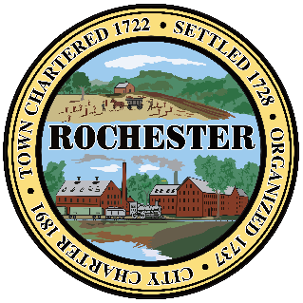
City of Rochester, NH
Office of the City Clerk
150 Wakefield Street, Unit 10
Rochester, NH
603-332-2130 / cityclerk@rochesternh.gov

Attention Voters:

Moderator’s Sessions: Testing the Counting Tabulators/ VotingWorks (VxScan) and the counting of the Official Ballots in preparation for November 4, 2025, Municipal Election.

Saturday, October 25, 2025
James W. Foley Community Center
Strafford Regional Planning Commission
150 Wakefield Street, Unit 12
Rochester, NH
(Conference Room 1-a)

8:00 AM (Ward 1 & 4)
9 AM (Wards 2 & 6)
11 AM (Ward 3 & 5)

