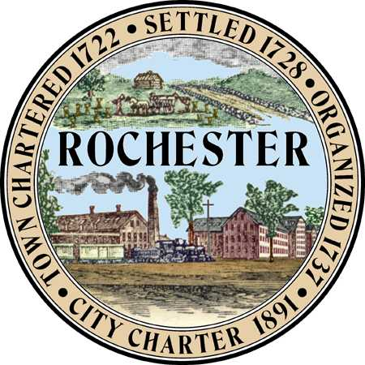
Planning & Development Department
Arts and Culture Commission
Matt Wyatt (Chair)
Cristina Dorvillier (Vice Chair)
Peter Ejarque
Martha Fowler
Elaine Lauterborn
Patricia O’Brian
Mike Provost
Amy Regan

City Hall - Second Floor
31 Wakefield Street,
Rochester, New Hampshire 03867-1917
(603) 335-1338 - Fax (603) 335-7585
Web Site: www.rochesternh.net

MINUTES
ARTS AND CULTURE COMMISSION
Thursday, June 19, 2014
City Council Conference Room
31 Wakefield Street, Rochester, NH
*see notes at end
Present | Absent
Patricia O'Brien
Elaine Lauterborn

Mike Provost
Matthew Wyatt
Martha Fowler
Amy Reagan
Cristina Dorvillier
Peter Ejarque
Michelle Mears, Staff support for Arts and Culture Commission

Guest

Call to Order

Matt Wyatt called the meeting to order at 7: 00 pm.

Approval of minutes

The Commission approved the May 15, 2014 meeting minutes Mr. Provost made the motion and Ms. Dorvillier seconded.

Achievement in the Arts awards
Mr. Provost had out the survey monkey for the Achievement in the Arts Awards. The group reviewed the information. The group will send out a press release to Main Street, Chamber of Commerce, City website, and Fosters Daily Democrat, Hippo, and the Rochester Times. The press release needs to be ready to go by this Monday. That will give a month to survey.

The staff support will get a Proclamation by the Mayor for the second week on August 2014 to be arts week in the City of Rochester. The Chair is requesting a key to the City.

PowerPoint Presentation Infinite Canvas

The presentation will be sent out to the group.

CDBG Bike Racks in City

Mr. Provost announced he won a bike rack that he will be donating to the City of Rochester. The group talked about the possibility of using Bike Racks as Public Art Displays in areas in the Downtown.

What is happening around Rochester?
Rochester Opera House

Summer Theatre Camp will run from July until August shows will include Mary Poppins, Broadway Revue, Sound of Music, and Cinderella.

Rochester Main Street

June 21 - "The Great Race" - Hanson Street, 12:00pm to 3:30pm

July 19 - Rochester Main Street Blues/BBQ Festival, sponsored by DF Richard, 11-4, North Main Street

July 30 - Teddy Bear Picnic at Central Square, 12-1, Bring your blanket, picnic lunch and Teddy Bear! Games/Music

Factory Court Concert Series Brown Bag Concerts are held on Fridays, June 27- August 29 from 11:45 am until 1:30 pm. Concert

August 11 - 2014 Rochester Achievement In The Arts Awards, The Garage Café, 5:00pm

Rochester was featured in NH Good Eats Magazine about top 10 things to do and see in Rochester.

Rochester has been added to Seacoast Shop Local listing.

RMFA
Ruth Dudley-Carr “Ex Nihilo: exhibit she is a visual artist based in Boston, MA.

They now have two new honorary committee members Daielle Krysa founder of the Jealous Curator and Geoff Pitchford Founder of Artistsaday.

Other Business

The City of Rochester has a new website please submit pictures to the Planning or Economic Development Department. Put a link on the website to the Achievement in the Arts Survey under News and Announcements.

Adjournment

Mr. Provost made a motion to adjourn at 8:05 pm, seconded by Ms. Dorvillier all were in favor.

Respectfully submitted,
Michelle Mears

