2024 Youth Cheer Handbook

Rec.rochesternh.gov

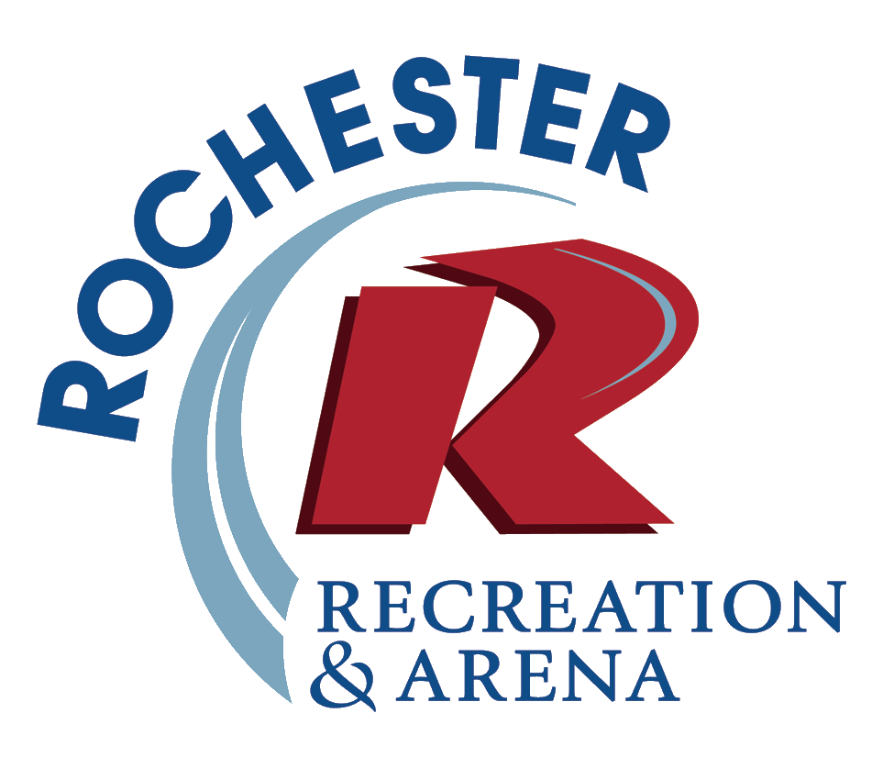

Youth Cheer Overview

At Rochester Rec, we believe the recipe for a great program is simple: provide a safe environment, keep kids active and having fun! Role model staff engage participants in sessions of age & skill appropriate cheer/spirit activities. The Rec Youth Cheer program strives to provide youth from Rochester and surrounding communities with positive childhood experiences and a sense of belonging. We look forward to welcoming families into this new community tradition!

This program is an opportunity for kids to cheer through the winter for the Rec Basketball Teams. The program will include sideline cheer, as well as all other aspects of cheer, such as routines, dances, stunts, etc. This is a great way to get them ready for higher levels or cheer. The overall goal is to have a fun and great season.

Practices will be held on Mondays from 5:00-6:30 in the upstairs fitness room at the Rochester Arena at 63 Lowell St. Enter through the glass door on the front of the building and the stairs are on the right. Games on Saturday are tentatively scheduled to be played between 11-2.

Important Dates

Friday, December 1 – Registration begins
Sunday, December 31 – Registration ends
Monday, January 8 – Practices begin at the Rochester Arena – 5:00-6:30
Saturday, January 13 – First Day of the 2024 Regular Season for Rec Ball! (See schedule below)
Saturday, January 20 – Picture Day
Saturday, March 2 – Last day of regular season for Grades 1-4. Playoffs for Grades 5-12 during regular time slot.
Tuesday, March 5 – Championship Games – Grade 5/6 – 6:00pm; Grade 7/8 – 7:00pm; Grade 9-12 – 8:15pm

A Typical Saturday Cheer Schedule

5th/6th Grade Co-ed Full Court Games (3 games at 11:15am-12:30pm & one game at 12:45pm-2:00pm)
7th/8th Grade Co-ed Full Court Games (2 games at 1:00pm-2:00pm and 1 game at 2:15pm-3:15pm)

Being Prepared for Cheer

To ensure a safe, fun, and healthy day for your child/children, the following items are needed.

Essentials - THE BIG 5!
1) Water Bottle – we have a refilling station
2) Game Shirt - most should be available on Jan. 13
3) Shorts/Sweats
4) Sneakers
5) Pom-Poms

Rec Cheer Expectations

The following list highlights the skills that help a child have a healthy, happy cheer experience. If you feel that your child is not a good candidate or may not be able to do these things independently, please contact Recreation staff who can provide information and resources to assist with making this a positive childhood experience.
A Happy Rochester Rec Basketball Program Participant…
· Follows instruction in a large or small group dynamic
· Is willing to participate at Practices and Games (Grades 5-8)
· Works well with others in both small and large groups
· Enjoys walking/running and being physically active
· Understands the concept of respect for self and others
· Uses appropriate language

Additional Support
We understand that some children may need additional support to meet the list above. While we do not provide one on one support staff to program participants, we welcome children who will be accompanied by a support person from an established agency or privately hired by the family. To explore this collaboration, please contact Recreation Supervisor Jeff Turgeon at Jeffrey.turgeon@rochesternh.gov.

Inclement Weather

Rochester Recreation makes every effort to maintain the basketball/cheer schedule. However, snow/ice storms or extremely cold weather may force us to cancel/postpone practice/games. Our website, email, Facebook, and Instagram will be used to get the word out. Practices and games may be rescheduled if time and space in a facility allows.

Cheer Appropriate Clothing

Participants will spend most of the session moving around. Clothing should be comfortable. Rec issued t-shirts and comfortable shorts are encouraged. NO alterations to Rec issued t-shirts! This includes cutting or tie-dyeing. Participants who alter their shirt will not be allowed to participate until they purchase a new shirt. This is to promote uniformity and professionalism. Non-Rec shirts may be worn for practice.

Footwear
Participants should be wearing sneakers for practices and games. Please help keep our floors clean and dry by wearing boots/other outside footwear into the Rec Center/Arena then changing into sneakers before entering the gym/fitness room.

Water Bottle

Participants should bring a refillable water bottle (larger than a 12-20 oz bottle) to practice and games labeled with their first and last name. There is a water bottle refilling station in the Rec Dept. Hallway. Soda and energy drinks are highly discouraged!

Hair & Jewelry

Participants who have hair that is long enough to be tied back should wear it tied back for practices, and games. Tying one’s hair back also helps to prevent getting caught in something and causing an injury and allows for staff to clearly see a participant’s face to assess wellbeing. Participants should not wear any jewelry (rings, necklaces, watch, bracelet, etc.) that may be a safety issue to themselves or others during cheer activities.

Behavior Expectations

All participants and spectators are expected to behave in a safe, responsible, respectful manner towards themselves and others. This will be demonstrated by listening to the directions of Recreation Staff, remaining within designated Rec Dept boundaries, and embracing the following Roch Rec Dept values. In alignment with the Rochester School District, Rochester Rec Basketball participants and staff commit to practicing and embracing the following guiding principles:
- Be Safe.
- Be Responsible.
- Be Respectful.
Positive Behavior

Examples of how our three guiding principles can be demonstrated are:

Be Safe. | Keeping hands to self, except during appropriate basketball activity.  Using equipment and play materials responsibly.  Stay in designated areas.  Follow proper personal hygiene guidelines.
Be Responsible. | Following rules of the game/activity.  Listening to adult directions.  Cleaning up after activities.  Reporting problems to Rec Staff.
Be Respectful | Using kind words and tone with others.  Looking at and listening to peers and Rec Staff when they’re speaking.  Sharing equipment and play materials.

Parent/Guardian and Staff Communications

Rochester Recreation believes that a successful cheer experience requires a relationship of respect between Rec Staff and parents/guardians. Demonstrating positive adult interactions is crucial for setting healthy examples for all participants. Communication between parents and Rec Staff is expected to be appropriate and professional. If a parent/guardian is communicating in a hostile, disrespectful manner to Rec Staff, proper follow up will take place by Recreation administrative staff and the participant/coach/spectator could be removed from the program. If a parent/guardian has concerns, questions or feedback that may result in a high stress conversation, they are strongly encouraged to bring them directly to the Recreation Supervisor and/or Assistant Director. Our number one goal in parent/guardian and staff communication is to ensure a safe, comfortable, and healthy environment for all involved.

NOTE: It is the responsibility of the parent/guardian to be accessible by phone during the practice/game to ensure that we can make contact for any participant needs. It is also the responsibility of the Parent/Guardian to update the office of any changes to their contact information as soon as they are changed. Failure to update contact information may result in dismissal from the program.

Stay Informed During the Season!

A fun, healthy cheer program experience relies on teamwork and communication between Rec Staff and parents/guardians. To ensure a positive experience for all, Rochester Recreation encourages parents/guardians to check their email daily for cheer program updates as email, primarily sent through RecDesk, is our primary mode of communication. Program updates are also posted on our website, rec.rochesternh.gov, as well as our Facebook and Instagram pages.

Lost, Broken or Stolen Items

Rochester Recreation is not responsible for broken, lost, or stolen items. If an item is broken, lost, or stolen, please report it to Rec Staff immediately. An incident report will be filled out and turned in to the Recreation Office.

Maintaining a Healthy Program

We must take reasonable steps to reduce and control the spread of communicable diseases within the cheer program. Participants should not attend practice or games if they are sick. Depending on the circumstances, a doctor or health care provider note may be required to return. Please help us keep our participants and staff healthy - if you or your child/children are not feeling well, please stay home.

Cheer Program Tuition Refunds

Our staff values participant feedback about our programs and we always try to find fair, appropriate solutions to any challenges that may arise. It is our hope and expectation that parents/guardians will communicate concerns about our programs to Rec Staff prior to requesting a tuition refund so that we may explore various solutions to their concerns. If a situation occurs that causes a parent/guardian to request a refund, such requests must be submitted to the Recreation Supervisor in writing. All refund requests are dealt with on a case-by-case basis and require a meeting between the parent/guardian(s) and the Recreation Supervisor. For refund requests that are approved, no cash refunds are given, and distribution of a refund check will take up to 4-6 weeks to be processed and mailed. Credit/Debit card refunds typically appear in about a week or so.

Recreation Department Location and Contact Information

Rec Office Location: The Recreation Office is located inside the James W. Foley Memorial Community Center. If you need to come to the office, please use the doorbell located to the right of the Recreation Department Main Entrance doors. Recreation staff will let you in. Please be patient as we may not be able to respond quickly depending on what we are doing or where we are in the building.

Recreation Office Phone: 603-332-4120
Department Website: Rec.RochesterNH.gov
Department Facebook: Rochester NH Recreation & Arena
Department Instagram: rochester_rec

Staff Contact:
During the cheer season, we encourage families to communicate with coaches and Program Leaders with any suggestions, concerns, or general feedback. Questions or concerns regarding the cheer program can be directed to:

Jeff Turgeon
Recreation Supervisor
Jeffrey.Turgeon@rochesternh.gov
(603) 332-4120

Subject to Change

Please note that while we do the best that we can to cover all topics and questions in this handbook, the policies outlined here are subject to change.

